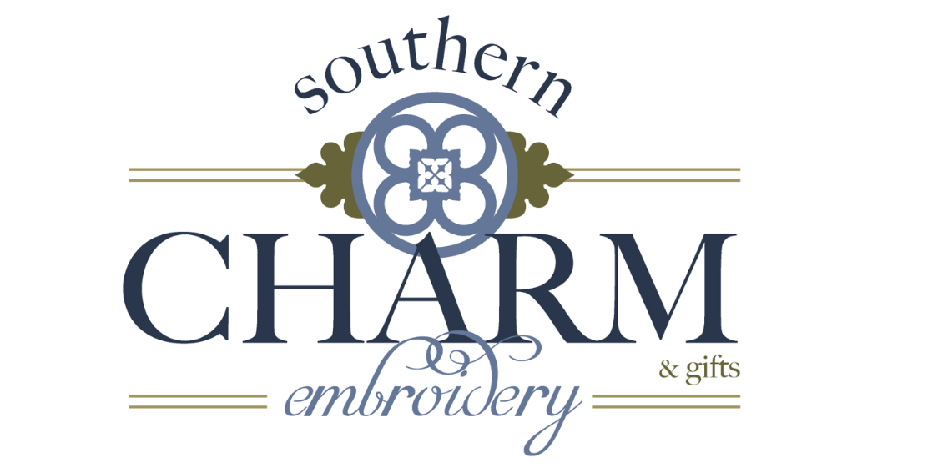
660 Old River Road
Meldrim, Georgia 31318
(912) 748-5733

Disclaimer/Indemnity:

I hereby certify that I either own the copyright to the design, mark, words, symbols and all areas related to the design or that I am legally licensed to use the design and I agree to fully indemnify and hold Southern Charm Embroidery and it’s agents, officers, representatives and employees harmless against any damages, cost, claim, judgment, and/or expense (including attorney’s fees and all legal fees) relating to, or by reason of any actions based on the infringement thereof.

______________________________ ______________________________
PRINT NAME COMPANY NAME

_____________________________ ____________________________
SIGNATURE DATE

______________________________
TITLE

I give Southern Charm Embroidery permission to post photos of completed work containing my logo on all social networking sites (Facebook, Pinterest, Instagram, etc.) as well as our website, southercharmembroidery.com

___________________________________ ______________________________________
PRINT NAME COMPANY NAME

____________________________________ ________________________________________
SIGNATURE DATE

