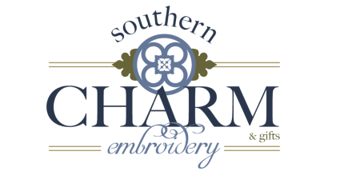

Donation Request-
Thank you for reaching out to Southern Charm Embroidery. There are many wonderful charitable causes and Southern Charm Embroidery would like to help as much as possible. Donations are an important aspect of SCE’s community involvement. Due to high demand and limited resources, SCE gives first priority to requests that come from non-profit organizations. While we absolutely adore your children and applaud all their efforts in staying active, we are not able to donate to all of the requests we get. Most certainly, if we could, we would! Please understand that sending in a request does not guarantee product or funds.
Please allow sufficient time for donation requests to be processed. All donation requests must be received at least one month prior to the requested need date. There are no exceptions. SCE only donates one time per calendar year to an organization, on a first come first serve basis. Your current tax-exempt certificate number (501c3) is required for our records for each request submitted.
We wish you the best in your fundraising efforts! By completing this form, you are agreeing that it is permissible for Southern Charm Embroidery to list your name as a recipient of an auction item or funding in our annual report.
Requestor Information:
Date of Request__________________________________________________________________
Contact Name_____________________________________________________________________
Organization Name_________________________________________________________________
Address__________________________________________________________________________
Phone Number ____________________________________________________________________
Email____________________________________________________________________________
Charity Event or Organization Name and Brief Description__________________________________
_________________________________________________________________________________
Type of Organization_______________________________________________________________
(Non-Profit, Charity, Corporation, Foundation, Civic Group, Organization, Individual, Church, Other)
Date Donation is Needed____________________________________________________________
Tax ID/EIN________________________________________________________________________
Contact Signature and Date__________________________________________________________
Please complete the form below and send all required documents for consideration to:
Southern Charm Embroidery
Donation Request
PO Box 77
Meldrim, GA. 31318
sales@southerncharmembroidery.com

